**Project Report**



**Carrio Motors**

|  |  |
| --- | --- |
| **SUPERVISED BY** | Sir Tameez Nawab |
| **Group Members** | Muhammad Taha Ghous (Student 1494722) |
| Muhammad Hassan (Student 1491044) |
| **BATCH** | PR2-202307F1 |

Table of Contents

**CERTIFICATE** 3

**Acknowledgement** 4

**Project Synopsis** 5

**Functional Requirement** 6

**Problem statement** 7

**Proposed System** 8

**Hardware/ Software Requirements** 9

Hardware 9

Software 9

Other Requirements: 9

**Website features** 10

**Flow diagram** 11

**User Guide** 12

• *Homepage (landing Page)* 12

• *INVENTORY* 14

• *FINANCE* 16

• *WARRANTY* 17

• *ABOUT US* 18

**Developer’s Guide** 19

• MAIN DIRECTORIES 19

• HEADER 20

20

• Cards (Dynamically Created) 22

➢ **Home Featured Vehicles Cards (Dynamically Created)** 22

➢ **Inventory Featured Vehicles Cards (Dynamically Created)** 25

➢ **Finance Scheme Cards (Dynamically Created)** 27

➢ **Warranty Scheme Cards (Dynamically Created)** 29

30

• ABOUT US 32

• Contact 34

• Footer 35

**TASK SHEET** 36

# **CERTIFICATE**



# **Acknowledgement**

First of all, we would like to thank Almighty Allah for giving us strength and ability to complete this project.

And then, we would like to express my special thanks of gratitude to our teacher **Sir Tameez Nawab** who guided us on the project***“CARRIO MOTORS****”*, which also helped us in doing a lot of new learning and we came to know about so many new things we are really thankful to him.

We are highly thankful to **Sir Tameez Nawab** for his guidance and constant supervision as well as for providing necessary information regarding the project & also for his support in completing the project.

Lastly, we would also like to thank our parents and friends who helped us a lot in finalizing this project within the limited time frame. We also express our sincere gratitude to E-Project team from Aptech Head Office, for their valuable guidance and support for the completion of this project. We earnestly hope that this project will provide all the necessary information required by the user to fulfill his/her inspiration. However, suggestion and Feedbacks for improvements will be thankfully welcomed & acknowledged*.*

# **Project Synopsis**

Carrio Motors is one of the fastest growing Dealerships. We focus on delivering high Customer Satisfaction Standards. All employees are committed to provide service with Discipline, Focus and Speed, by following all Standard Operating Processes defined by our company

Our Dealership's presence is well spread across country with all our showrooms more than 8000 sq. ft. Our Service centers are located strategically to offer best service to our customers. We proudly carry brands such as BMW, Audi, Hyundai, Suzuki, Kia, Morris Garage and more.

# **Functional Requirement**

1. The Top of the Page should be presented with a suitable logo and scrolling images of cars.
2. Brand wise categorization of Cars should be provided in the website.
3. A menu which will include all the functions implemented in the site.
4. Clicking on a car picture should open popup window with car details and specifications. The details include features, price, location of the dealer etc.
5. Site should also include the section that will give the information about the warranty schemes on the cars. The scheme will be different for the different brands.
6. Section for Finance option should be provided. It should list various schemes on different models and brands.
7. Site map, about us, contact us link must be added.
8. About Us and Contact Us: This menu option should display Email id, address, and contact number of the organization.

**Over and above this, the portal should implement the following functionalities:**

* Display a continuous scrolling ticker at the bottom of the page with current date, time.
* Display a visitor count at the top right corner of the page beside a logo image.
* The menu options should change color on hover.
* Fade in and fade out options can be used for the menus.

# **Problem statement**

Carrio Motors is one of the fastest growing Dealerships. We focus on delivering high Customer Satisfaction Standards. All employees are committed to provide service with Discipline, Focus and Speed, by following all Standard Operating Processes defined by our company

Our Dealership's presence is well spread across country with all our showrooms more than 8000 sq. ft. Our Service centers are located strategically to offer best service to our customers. We proudly carry brands such as BMW, Audi, Hyundai, Suzuki, Kia, Morris Garage and more.

# **Proposed System**

The company aims to break new ground by harnessing the power of technology and revolutionizing processes to make car ownership for the customers a truly enjoyable and hassle-free experience. So, taking into consideration the expanding business, the company planned to host the primary information through its website.

# **Hardware/ Software Requirements**

## Hardware

* Intel Core i3/i5 Processor or higher
* 8 GB RAM or above
* Color SVGA
* 500 GB Hard Disk space
* Mouse
* Keyboard

## Software

* Technologies to be used:
* Frontend: HTML5, CSS, Bootstrap, JavaScript, jQuery, AngularJS, XML
* Data Store: JSON files or TXT files

## Other Requirements:

* Operating Portal: Windows
* Browsers: Edge, Chrome, Mozilla Firefox, Safari

# **Website features**

Carrio Motors' website boasts a dynamic header with a logo and scrolling car images. Cars are conveniently categorized by brand and performance, facilitating easy navigation. A comprehensive menu grants access to various functions, including a detailed car popup displaying specifications. The site provides transparent information on warranty schemes and diverse finance options for different brands and models. Essential pages, such as Site Map, About Us, and Contact Us, enhance user experience. Advanced features like a scrolling ticker, visitor count, and interactive menu elements contribute to a visually appealing and informative platform, making Carrio Motors an accessible and engaging destination for car enthusiasts.

# **Flow diagram**

# **User Guide**

* *Homepage (landing Page)*

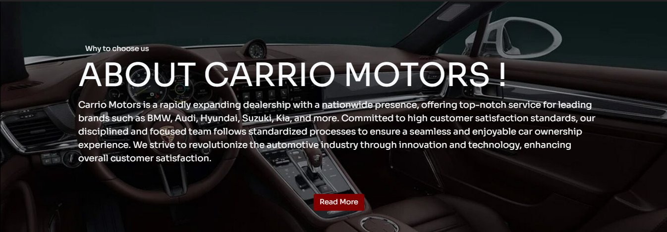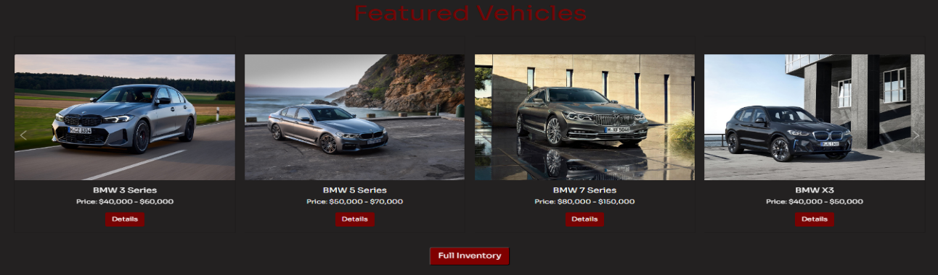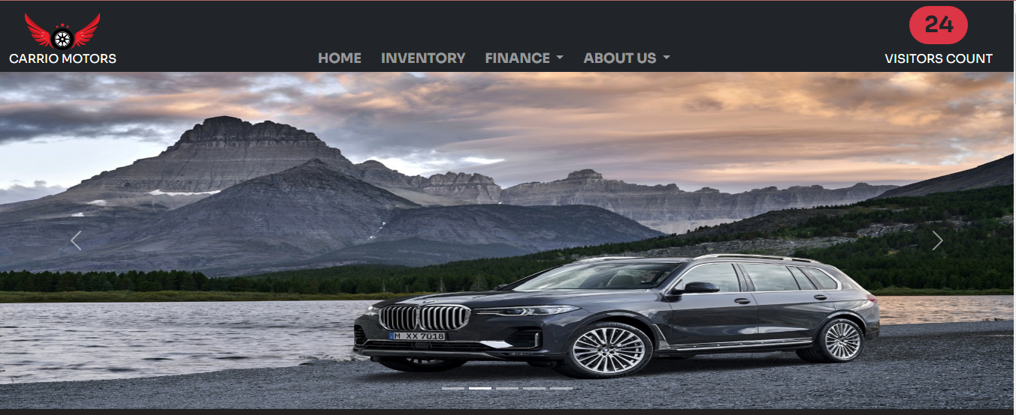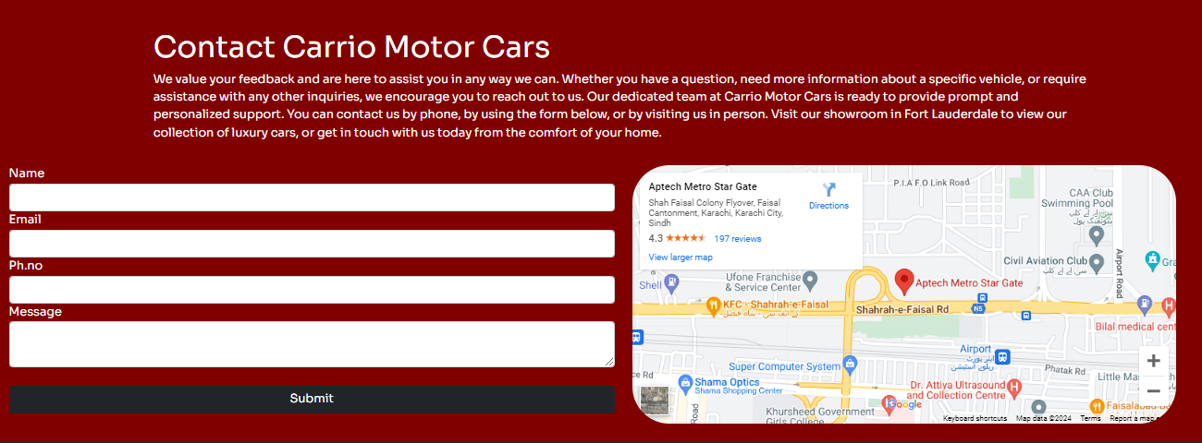

Creating a responsive website for "Carrio Motors" is a careful blend of design and functionality. The eye-catching logo establishes the brand's identity, accompanied by an orderly menu for easy navigation. The homepage grabs attention with the latest cars, guiding visitors seamlessly to a detailed inventory equipped with user-friendly search options. This user-focused approach extends to the finance page, providing clear information and a straightforward application process. The about us section adds a personal touch. Consistent color schemes, easy-to-read fonts, and quality imagery enhance the overall professional user experience. Through responsive design and user-friendly navigation, the website aims to engage, highlight the dealership's offerings, and create a positive, memorable impact on potential customers.

* *INVENTORY*

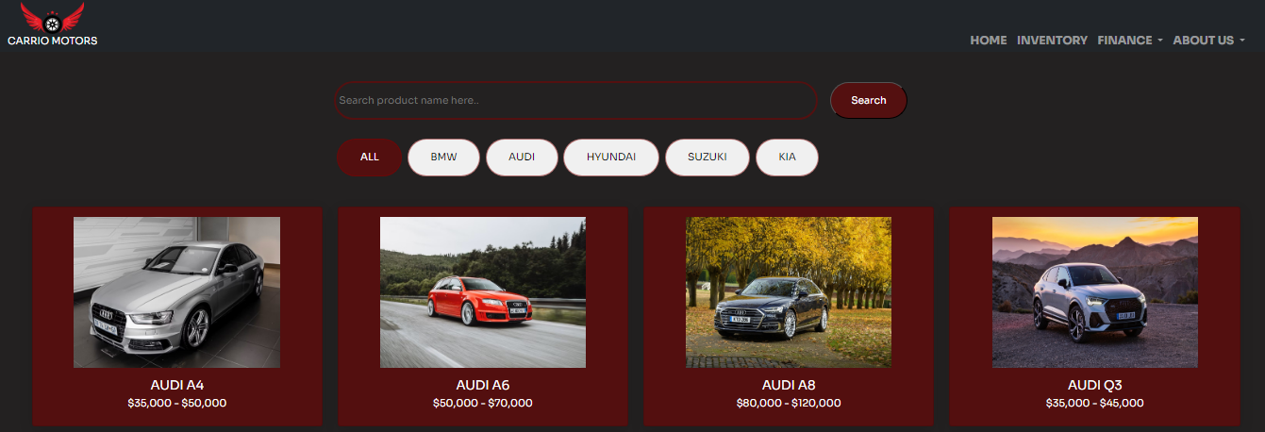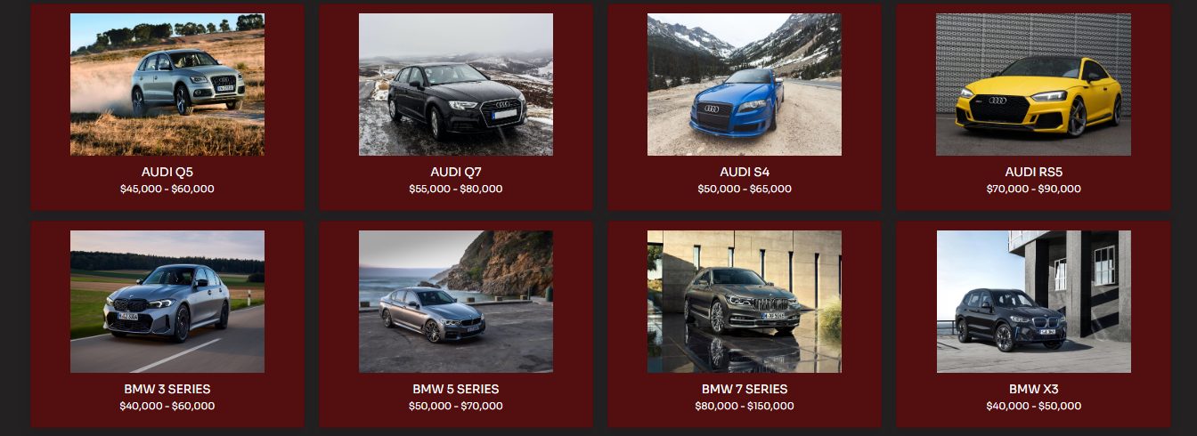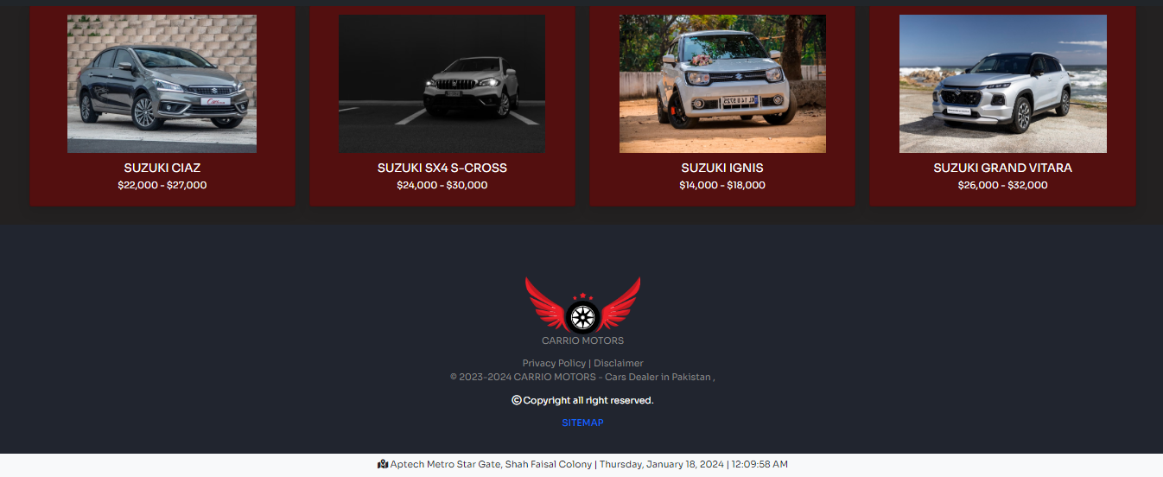

On the "Carrio Motors" website, the inventory is neatly arranged by brand, making it easy for users to find the cars they're interested in. Each brand has its own section, simplifying the exploration process. When you click on a car image, a window pops up with lots of details like features, price, and where the dealership is located. This smooth experience lets users learn all they need to know without leaving the main inventory page. The website's user-friendly design shows that Carrio Motors values being clear and making customers happy, making it enjoyable for everyone to explore the wide range of cars available.

* *FINANCE*

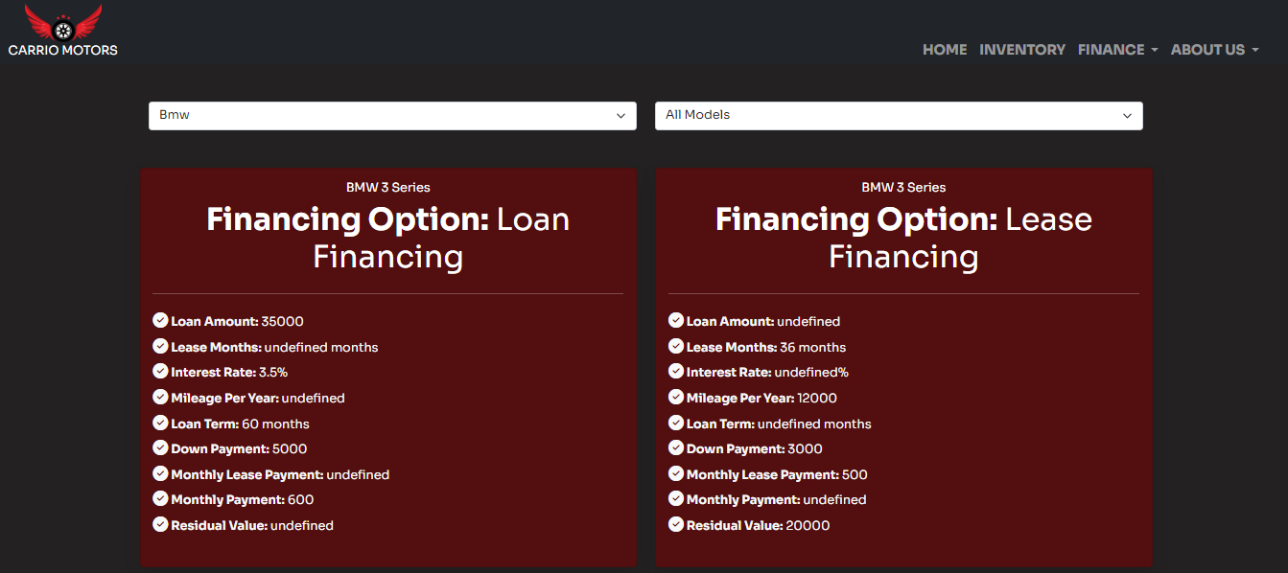

In the finance section of the "Carrio Motors" website, we offer two distinct financing options for each car model: loan financing and lease financing. For clarity and user convenience, each model is presented with two separate cards. One card provides details about the loan financing option, including interest rates, repayment terms, and any other relevant information. The other card outlines the lease financing option, offering details such as lease duration, monthly lease payments, and any specific terms associated with leasing.

* *WARRANTY­*

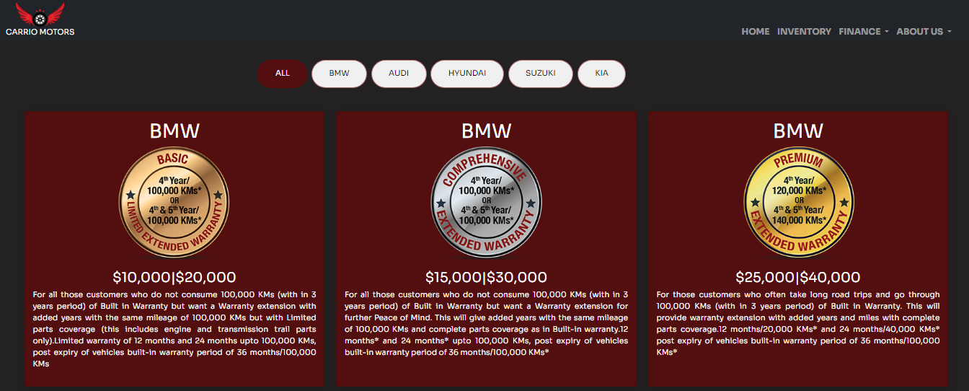

In the warranty section of the "Carrio Motors" website, we present an overview of protection plans by offering three distinct warranty cards for each brand: basic, comprehensive, and premium. Each card delineates the specific coverage and benefits associated with the corresponding warranty package. This three-tiered approach allows customers to easily compare and choose the warranty plan that aligns with their preferences and needs. Whether opting for a basic level of coverage, a more comprehensive plan, or a premium package with extensive benefits, customers can make informed decisions about protecting their investment in a "Carrio Motors" vehicle.

* *ABOUT US*

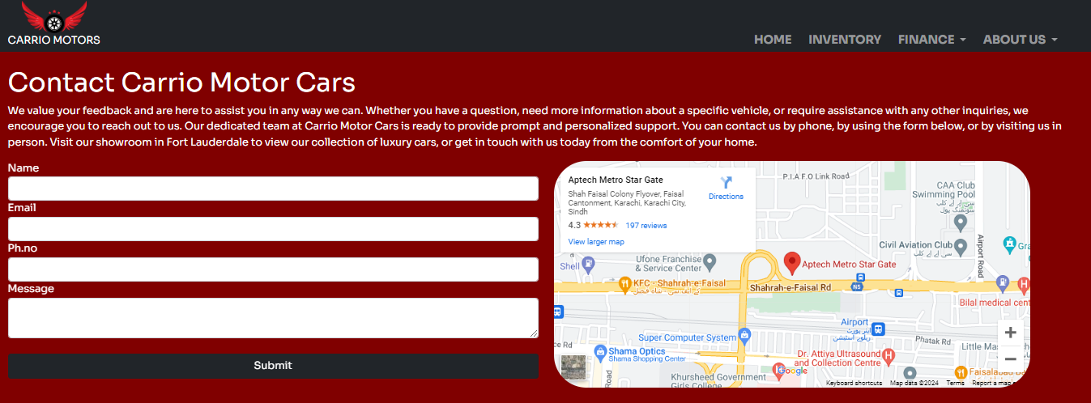

In the "About Us" section of the "Carrio Motors" website, we facilitate easy user contact through a user-friendly form that collects essential information, including name, email, phone number, and user inquiries. Simultaneously, we provide a visual display of our dealership's location, including the address and a map. This dual approach ensures seamless communication, allowing users to reach out digitally and locate our physical showroom effortlessly. Whether users have questions or plan to visit, the "About Us" section serves as a central point for effective and transparent interaction with Carrio Motors.

# **Developer’s Guide**

## MAIN DIRECTORIES

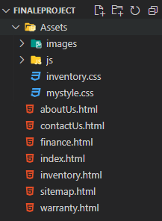

## HEADER

### 

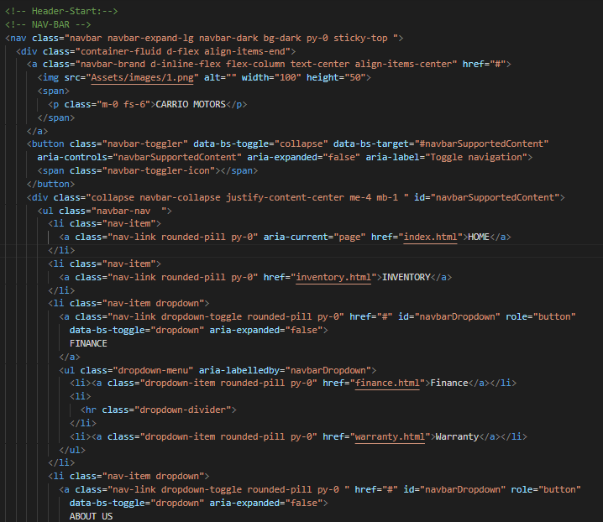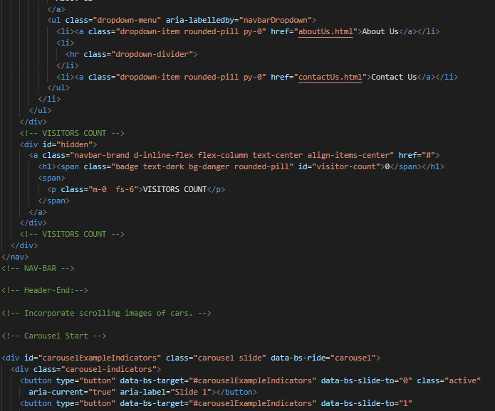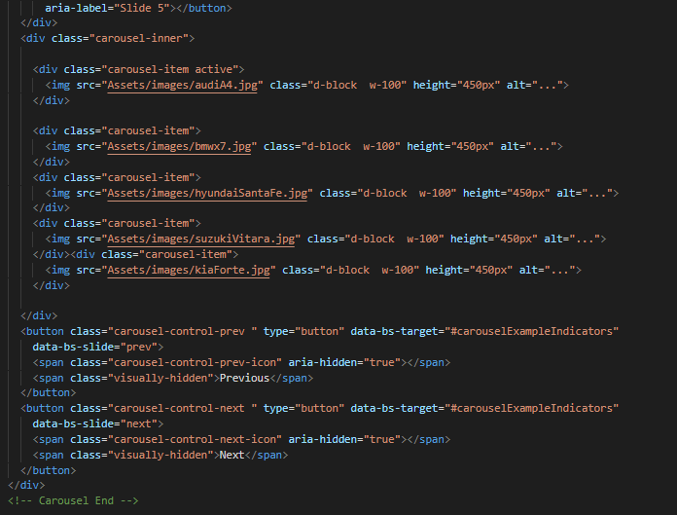

Creating a responsive website for "Carrio Motors" is a careful blend of design and functionality. The eye-catching logo establishes the brand's identity, accompanied by an orderly menu for easy navigation. The homepage grabs attention with the latest cars, guiding visitors seamlessly to a detailed inventory equipped with user-friendly search options. This user-focused approach extends to the finance page, providing clear information and a straightforward application process. The about us section adds a personal touch. Consistent color schemes, easy-to-read fonts, and quality imagery enhance the overall professional user experience. Through responsive design and user-friendly navigation, the website aims to engage, highlight the dealership's offerings, and create a positive, memorable impact on potential customers.

## Cards (Dynamically Created)

### **Home Featured Vehicles Cards (Dynamically Created)**

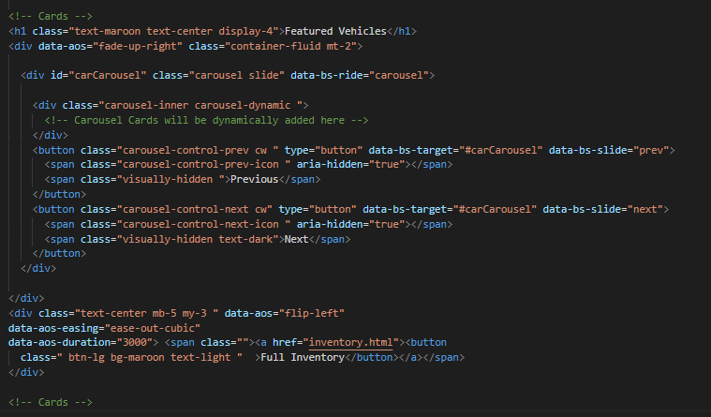

**JavaScript**

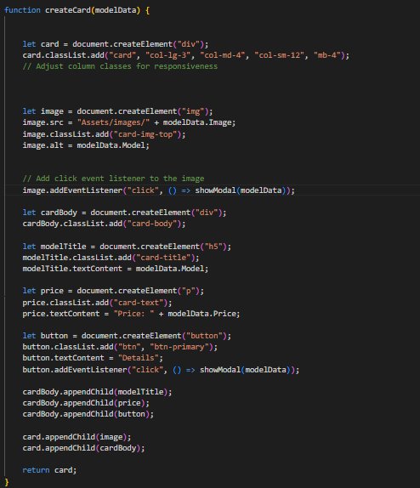

On the "Carrio Motors" website, the inventory is neatly arranged by brand, making it easy for users to find the cars they're interested in. Each brand has its own section, simplifying the exploration process. When you click on a car image, a window pops up with lots of details like features, price, and where the dealership is located. This smooth experience lets users learn all they need to know without leaving the main inventory page. The website's user-friendly design shows that Carrio Motors values being clear and making customers happy, making it enjoyable for everyone to explore the wide range of cars available.

### **Inventory Featured Vehicles Cards (Dynamically Created)**

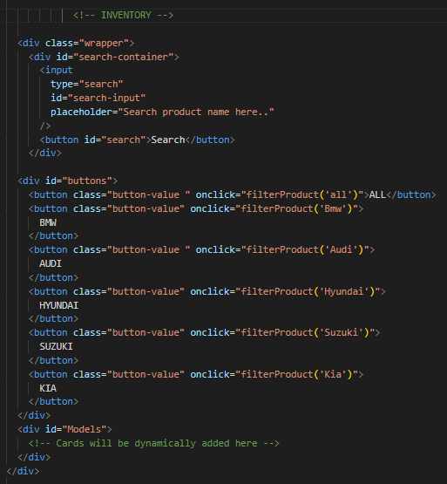

**JavaScript**

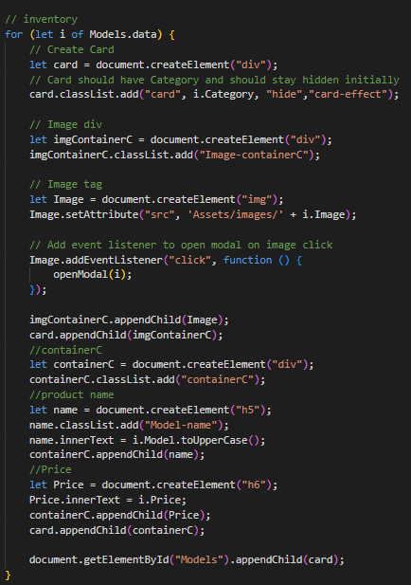

### **Finance Scheme Cards (Dynamically Created)**

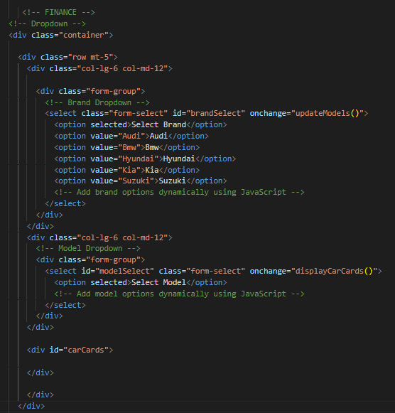

**JavaScript**

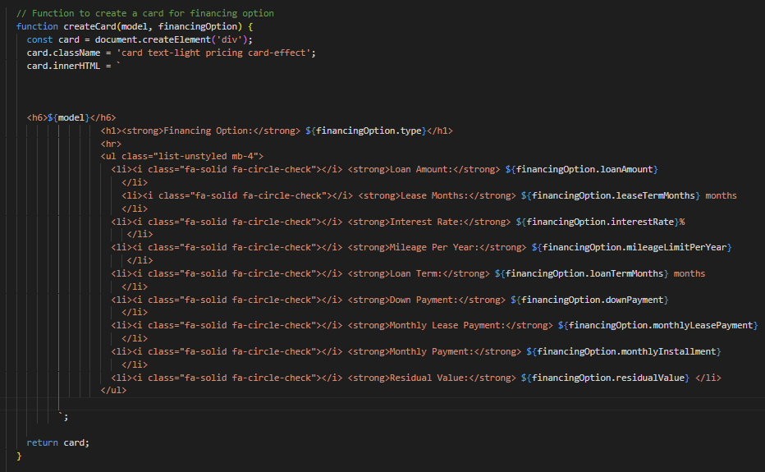

In the finance section of the "Carrio Motors" website, we offer two distinct financing options for each car model: loan financing and lease financing. For clarity and user convenience, each model is presented with two separate cards. One card provides details about the loan financing option, including interest rates, repayment terms, and any other relevant information. The other card outlines the lease financing option, offering details such as lease duration, monthly lease payments, and any specific terms associated with leasing.

### **Warranty Scheme Cards (Dynamically Created)**

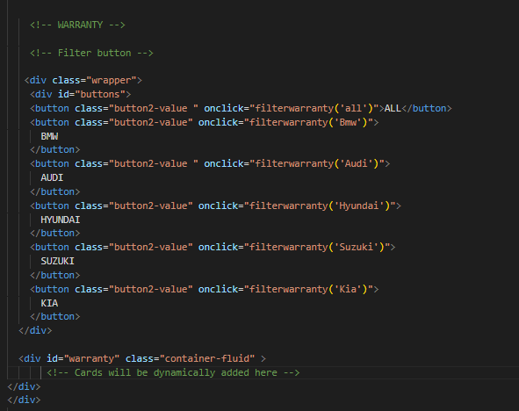

**JavaScript**

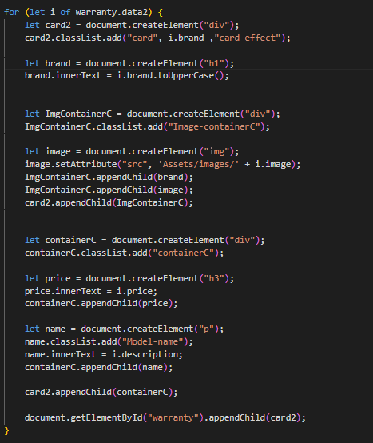

In the warranty section of the "Carrio Motors" website, we present an overview of protection plans by offering three distinct warranty cards for each brand: basic, comprehensive, and premium. Each card delineates the specific coverage and benefits associated with the corresponding warranty package. This three-tiered approach allows customers to easily compare and choose the warranty plan that aligns with their preferences and needs. Whether opting for a basic level of coverage, a more comprehensive plan, or a premium package with extensive benefits, customers can make informed decisions about protecting their investment in a "Carrio Motors" vehicle.

## ABOUT US

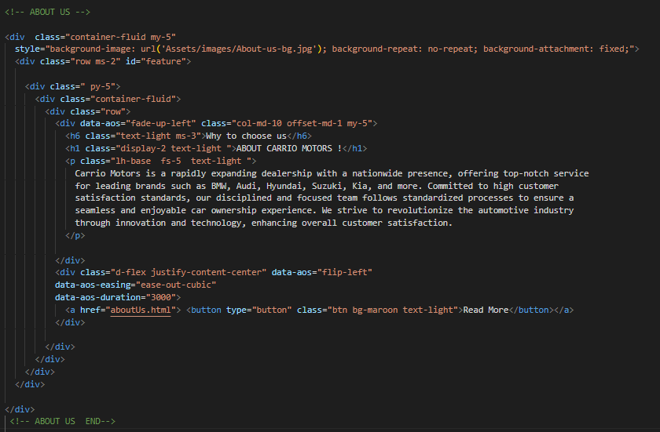**HTML**

**JAVASCRIPT**

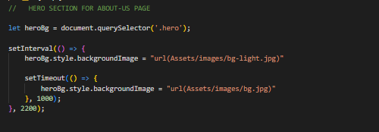

In the "About Us" section of the "Carrio Motors" website, we facilitate easy user contact through a user-friendly form that collects essential information, including name, email, phone number, and user inquiries. Simultaneously, we provide a visual display of our dealership's location, including the address and a map. This dual approach ensures seamless communication, allowing users to reach out digitally and locate our physical showroom effortlessly. Whether users have questions or plan to visit, the "About Us" section serves as a central point for effective and transparent interaction with Carrio Motors.

## Contact

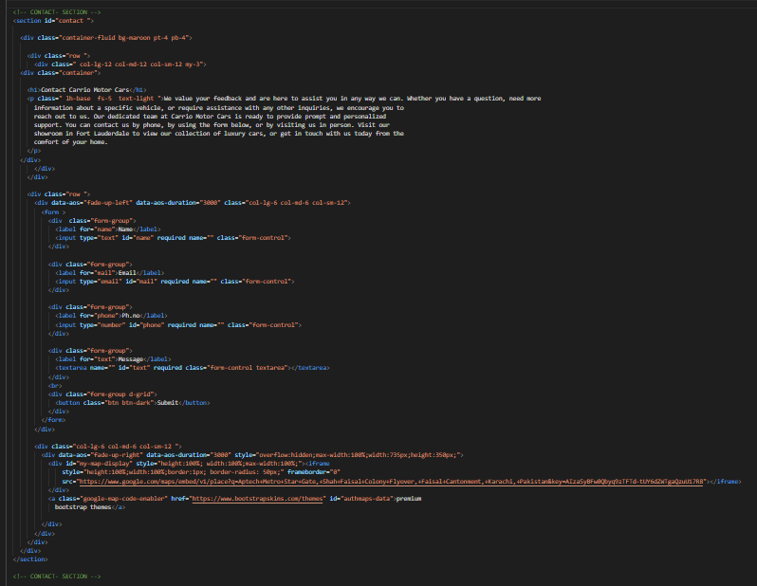

In this code, we facilitate easy user contact through a user-friendly form that collects essential information, including name, email, phone number, and user inquiries. Simultaneously, we provide a visual display of our dealership's location, including the address and a map. This dual approach ensures seamless communication, allowing users to reach out digitally and locate our physical showroom effortlessly. Whether users have questions or plan to visit.

## Footer

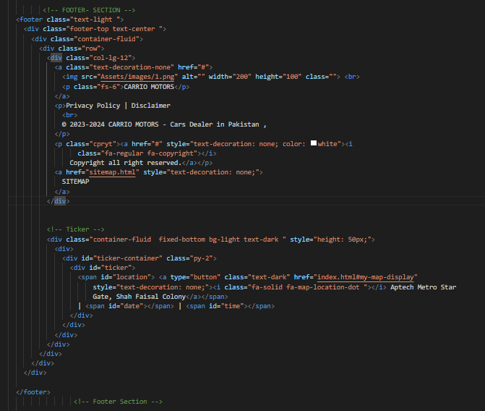

this code creates a footer for a website that includes branding, privacy policy, disclaimer, copyright information, and a continuous scrolling ticker displaying the current location, date, and time. The footer is designed to be visually appealing and informative, providing essential details about the company and website.

|  |  |  |  |  |
| --- | --- | --- | --- | --- |
| Project Ref. No. | | Project Title | Date of Preparation of Activity Plan | |
| S.No | Task | CARRIO MOTORS | Actual Days | Status |
| 1 | Analysis | 2 | OK |
| 2 | Design | 6 | OK |
| 3 | Development | 10 | OK |
| 4 | Testing | 3 | OK |
| 5 | Documentation | 2 | OK |

# **TASK SHEET**